https://tijdschrift.jilster.nl/pageflip/9cb1f5e6-c44b-11eb-afa6-020f06a3d4ed
STEAM TIME DIGITAL BROHURE OF THE WHOLE PROJECT

http://steamtime.eu/ WEB STRANICA PROJEKTA

AKTIVNOST RUMUNJSKA
4 October 2019
Today we travelled by bus for several hours. After the great farewell party with students, host parents and school yesterday night, this morning we left Galati very early for Gura Homorului. During this long trip we have had the opportunity to observe the Romanian landscapes changing, from the long corn plains to its forests in the mountains, we have seen its typical houses with sloping roofs and some details of the people's life along the roads we crossed. Even the weather changed from a warm temperature to an autumnal atmophere.
After lunch, we visited the Voronet Monastery. Here we lived a religious moment reciting the Our Father each country in own language. Then we went to visit Humor Monastery. Both monasteries are UNESCO heritage, both are totally covered of wonderful frescoes. Then, after a fast shopping of souvenirs, we gone on our trip for Sighisoara. Students spent their time in the bus chatting each other, listening music and sleeping. In the evening we arrived at the hotel very tired, ready for the dinner and, finally, for relaxing!
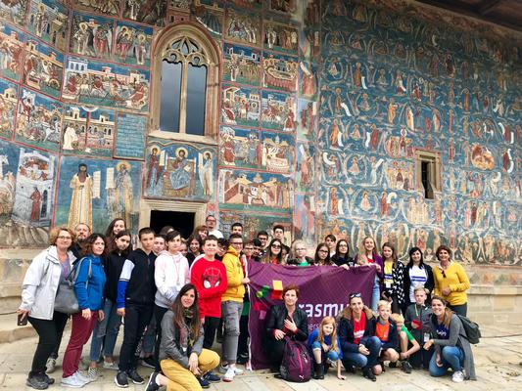
Another exciting sunny project day in Romania started with a trip to an etnographic museum Vatra cu Dor. In this interesting place project participants had a real lesson of folk history and local customs. We could not only see and touch numerous objects connected with the rural life but also admire sophisticated colourful patterns on beautiful shirts, jackets and table clothes or napkins. The guide explained the meanings of floral and animal symbols to us and also showed us how to make pottery items. Everybody could taste delicious homemade local donuts called gogosi and learned how to dance traditional dances. Finally there was time for putting on symbolic masks and taking photos. We had a lot of fun looking at each other and trying to guess who the people in masks were. Afterwards we went to a charming restaurant hidden in the beautiful park and had lunch there. In the afternoon we spent a lovely time in another park. After a short visit to a fishing museum we watched an incredible music performance of local songs and dances. It was a really amazing experience. After that there was a treasure hunt and another challenge for the students to show their skills, abilities and talents. The tasks weren't easy so the competition was very hard but everybody had a great time while solving project tasks in the fresh air. We came back to Galati a bit tired but happy and full of new experiences.
This wonderful day finished with the common dinner in which teachers, paremts and students attended. This time, however, not the food was the most important but chatting to new friends, sharing experiences, opinions and phone numbers as for the foreign teenagers it was the last evening in Galati.
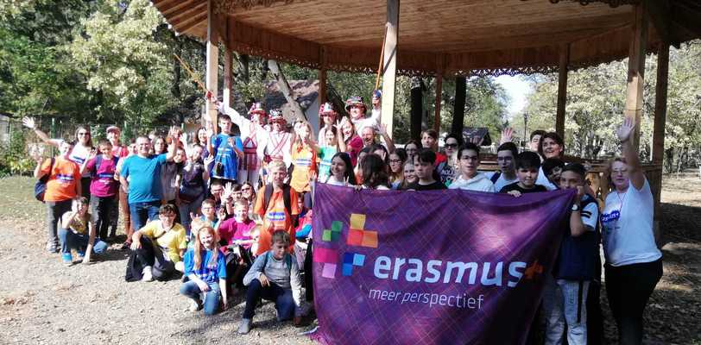
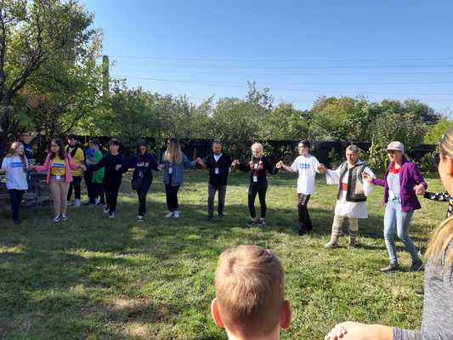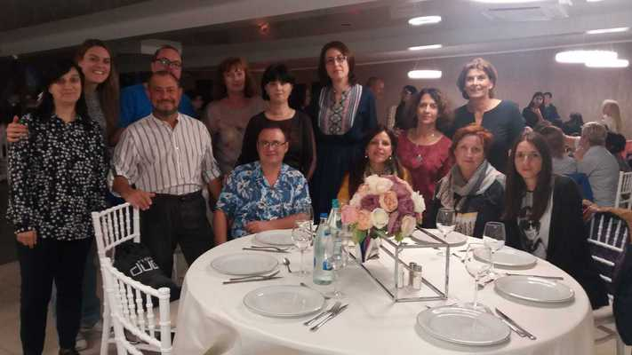
Tuesday 1 October
Today we started the day very early. Teacher's and the children that are staying in the hotel gathered at 5.30 in font of the bus and than we went to pick the rest of the pupils. Host families arrived with the kids before 6am and at 6am we where all together ready to continue our Romanian adventure.
Schedule for today was to get to Murighiol and to explore Uzlina channel and Uzlina lake so we had a long trip in front of us.
After few hours of driving with the bus we finaly came to Murighiol where we took the boat and divided in 4 groups and 4 boats we started our water adventure.
We enjoyed in beautiful nature, sounds of the nature, all sorts of different kind of the birds, fresh air and part of the Danube river. After few hours of this wonderful water pleasure we had lunch in the restaurant by the river.
Surroundings was wonderful, all around of us beautiful flowers and green grass so after the lunch we went outside, in the garden to resolve math tasks.
Tasks were connected with the UNESCO protected Danube Delta and Romanian mountains.
After we had a winner group of the day (in resolving the tasks) we went back on the boat and started our journey to go back to Galati.
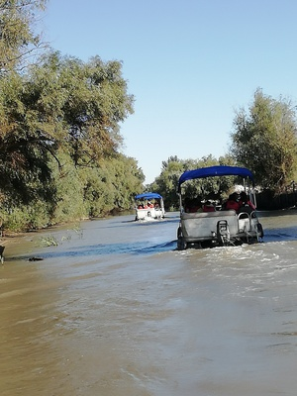
Monday 30 september 2019
Yesterday everyone arrived in Galati. We were all very excited for this week. This morning we all saw each other at the Constatin Gh. Marinescu school. It was a warm welcome. All the students and a lot of teachers were wearing traditional clothes. In the multi media room we all came together to introduce ourselves. The director welcomed us and we all received a nice bag with presents and an Erasmus+ t-shirt. All the children were devided in different groups and went to the gym to watch some traditional dances performed by the students of the Romanian school. At the end we all danced together. That was a lot of fun.
We visited the primary classes and did some activities together with the children of the school. After this activities we went for a very nice lunch. There was some traditional food. After that it was time to play together and to learn to know each other better. In the afternoon we visited the National Science museum and the Botanical garden. In both we solved some math tasks. Together we walked back to school and there we visited the secundary classes. All children enjoyed it very much. The children that went to families left with the parents. The children that stayed in the hotel went back with the teachers. The teachers had a teachersmeeting and afterwards we went for dinner.
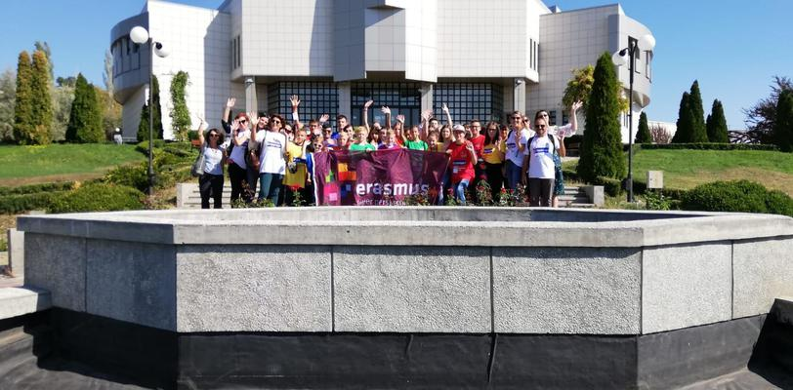
Friday 29th March 2019
Already the fifth and the last day of this wonderfull mobility in Italy. We started with a nice walk in Sambuca. Because of the rain a few days before, we couldn’t, and now was the best time. We saw the beautiful things Sambuca has to offer like the church, a very nice and old theater and some other sights. After the walk we were brought to Planeta, a very big winery in de surrounding and the local cheese farm, were we had a tour.
After this we went had a little break so we could rest and enjoy the sun for a bit. In the afternoon Italy had organised a seminar for all the parents, students and other involved. We presented our experiences and we looked back at a wonderfull week. After the seminar we went to the big square and were we saw a beautiful folk show. Last but not least we got surprised by a very good dinner in the pizzeria in Sambuca, were we said goodbye to all the involved.
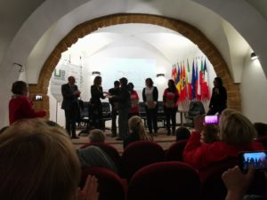
Thursday 28th March 2019
The fourth day was full of visits to UNESCO sites: we started with the Cathedral from Monreale, where we found a beautiful byzantine architecture, from which ceiling Gesu Cristo Il Pantocratore is looking to each visitor. Then we arrived in Palermo, where we visited the Palazzo Reale, Capella Palatina, the Cathedral of Palermo and students had to resolve some mathematical tasks. After that we enjoyed the visit to Antonio Pasqualino International Puppet Museum. The students had an workshop where they learned to make shields for puppets costumes and then they tried to manage the puppets. After that we all enjoyed a short spectacle with puppets, the famous UNESCO cultural heritage Teatro di Puppi. It was a long, but beautiful day, when we meet sicilian history and art.
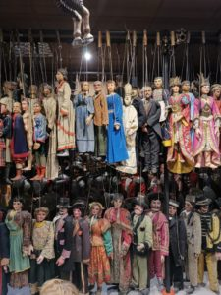
Wednesday 27th of March 2019
Today was the third day of our fabulos exchange. In the morning, during art workshops, we made ancient column of carton. After that, we played volleyball and football, which was really exciting to us. In the afternoon we had delicious lunch altogether. After lunch, while we were painting on the plot wonderful sights from yesterday’s trip , one of the Italian teachers was playing the guitar. The atmosphere was marvelous. In spite of being at school all day and bad weather, we really had great time together.
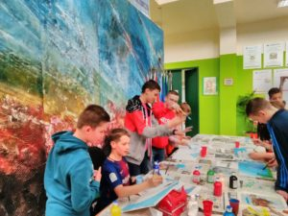
Tuesday 26th of March 2019
Today we went to explore old City Agrigento. First we have visited Valley of the Temples, best preserved archaeological sites of Greek civilization and that was amazing. We saw temple of Greek Gods Zeus, Hera , Jupiter and Hercules where we have done math laboratory. Later we went to see interior of the Green Parc Kolymbetra, park with more than 1500 plants, where we have done pottery workshop. During the lunch we tasted Italian specialities and after we went sightseeing Scalle dei Turchi, stone made trough years by the sea power where we did another math laboratory. Trough whole day our kids spent unforgettable time and we want to thank to our host for this wonderful day.
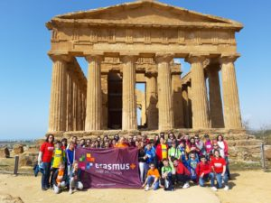

AKTIVNOST SICILIJA

Friday 29th March 2019
Already the fifth and the last day of this wonderfull mobility in Italy. We started with a nice walk in Sambuca. Because of the rain a few days before, we couldn’t, and now was the best time. We saw the beautiful things Sambuca has to offer like the church, a very nice and old theater and some other sights. After the walk we were brought to Planeta, a very big winery in de surrounding and the local cheese farm, were we had a tour.
After this we went had a little break so we could rest and enjoy the sun for a bit. In the afternoon Italy had organised a seminar for all the parents, students and other involved. We presented our experiences and we looked back at a wonderfull week. After the seminar we went to the big square and were we saw a beautiful folk show. Last but not least we got surprised by a very good dinner in the pizzeria in Sambuca, were we said goodbye to all the involved.
Thursday 28th March 2019
The fourth day was full of visits to UNESCO sites: we started with the Cathedral from Monreale, where we found a beautiful byzantine architecture, from which ceiling Gesu Cristo Il Pantocratore is looking to each visitor. Then we arrived in Palermo, where we visited the Palazzo Reale, Capella Palatina, the Cathedral of Palermo and students had to resolve some mathematical tasks. After that we enjoyed the visit to Antonio Pasqualino International Puppet Museum. The students had an workshop where they learned to make shields for puppets costumes and then they tried to manage the puppets. After that we all enjoyed a short spectacle with puppets, the famous UNESCO cultural heritage Teatro di Puppi. It was a long, but beautiful day, when we meet sicilian history and art.
Wednesday 27th of March 2019
Today was the third day of our fabulos exchange. In the morning, during art workshops, we made ancient column of carton. After that, we played volleyball and football, which was really exciting to us. In the afternoon we had delicious lunch altogether. After lunch, while we were painting on the plot wonderful sights from yesterday’s trip , one of the Italian teachers was playing the guitar. The atmosphere was marvelous. In spite of being at school all day and bad weather, we really had great time together.
Tuesday 26th of March 2019
Today we went to explore old City Agrigento. First we have visited Valley of the Temples, best preserved archaeological sites of Greek civilization and that was amazing. We saw temple of Greek Gods Zeus, Hera , Jupiter and Hercules where we have done math laboratory. Later we went to see interior of the Green Parc Kolymbetra, park with more than 1500 plants, where we have done pottery workshop. During the lunch we tasted Italian specialities and after we went sightseeing Scalle dei Turchi, stone made trough years by the sea power where we did another math laboratory. Trough whole day our kids spent unforgettable time and we want to thank to our host for this wonderful day.

AKTIVNOSTI HRVATSKA

- Dagmar Eskens
Monday 25th of March 2019
Last weekend all schools arrived in Sambuca di Sicilia. We are very excited to start this second exchange! When we arrived to the school we saw the entrance with all our flags. Italy organised a beautiful welcome program so we directly felt like home. Every country had prepared a small presentation to introduce themselves. We all got the Erasmus+ t-shirt with a some very nice welcome-presents. Also each country brought a ‘thank-you’bag from each country.After the presentations we had a little break and then we went outside for the second part of the welcome program. The whole school was there and all groups had prepared different kinds of acts for us. It was very nice!
We had a buffet in a very nice palace. After the lunch, we could rest for a bit and we went back to school. There were some different workshops: math lab – logical lab – ceramic lab – puzzle lab. We had a great first day and we are looking forward to the next one!
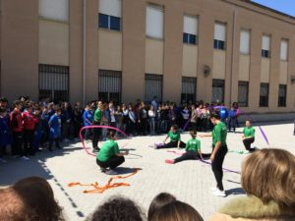
Friday 9th of November. Today was the last day of our wonderful exchange. We spent the morning with the boys and girls separately: the girls played handball while the boys solved crime math tasks and then the boys played football, while the girls solved the tasks. Then we had a really nice lunch all together. After lunch it was time to say goodbye.: we recieved our certifications and we thanked each other for the wonderfull week we spend in Seget Donji. We handed our flags over to Sicilia, Italy, where our next exchange will be. We are looking foreward to it! Thank you Croatia, for all the good care and great organisation and we will see each other soon again!
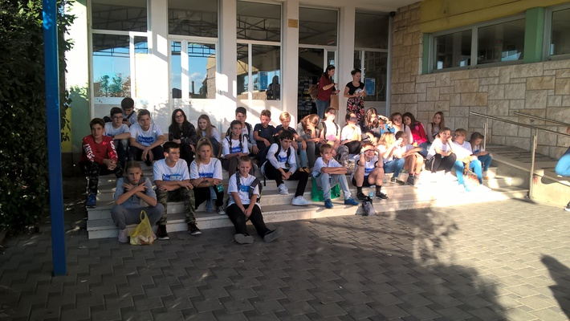
Thursday 8th of November. Today we spent learning more about the past of Croatian culture but also about the present. We began our day by going to Sinj to learn about the tournament like contest called Alka, inspired by the wars with the Ottoman Empire. We learned about the fact that each member of the alka had its own place and role in the procession. At the end of the tour, the children tried to catch the alka sign. We have also seen the icon of the Miraculous Madonna of Sinj inside its church. After this, we went to a Maritime museum, where we discovered a lot of new information about the Croatian presence in the nearby seas and land from ancient times up to the present. We have seen beautiful miniature ships and bits and pieces of naval engines and equipment. The other wing of the museum presented us with military equipment. The children worked on a workshop, learning how to tie different types of sailor’s knots. Finally, we went to Split and visited Diocletian’s palace, a very interesting historic site, maybe unique in the fact that people still live in the buildings that are within the palace’s walls. Passing by a sfynx, listening to a quartet of traditional Croatian singers, sightseeing Diocletian’s palace from the roof, and rubbing the toe of Catholic bishop which is said to make wishes come true, all these made Split an experience we’ll hardly ever forget.
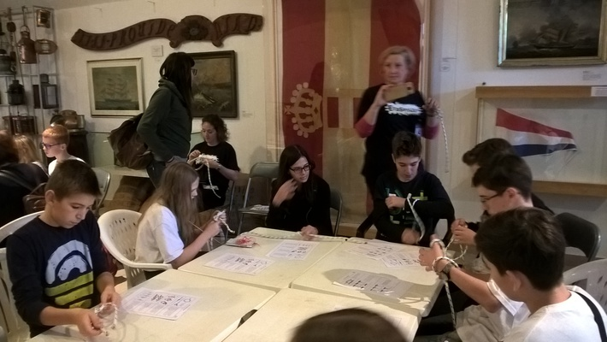
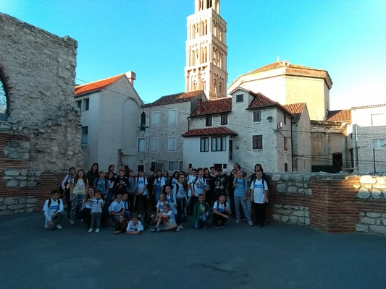

Wednesday 7th of November. Today we spent the morning in Trogir, an Unesco city close to Seget Donji. Our students discovered this wonderful place through a sort of “treasure hunting”. Each group had to find clues in 13 different locations of the city solving math tasks related to this impressive cultural heritage. Then, in the main square, there was a very interesting show with the typical dances, Dalmatian songs and modern majorette dances of the students enjoyed ourselves. In this occasion, the local authorities gave us a very special and official welcome and the consols of our countries were presents as well. We had a very good organised lunch were we could even try each countries specialities!
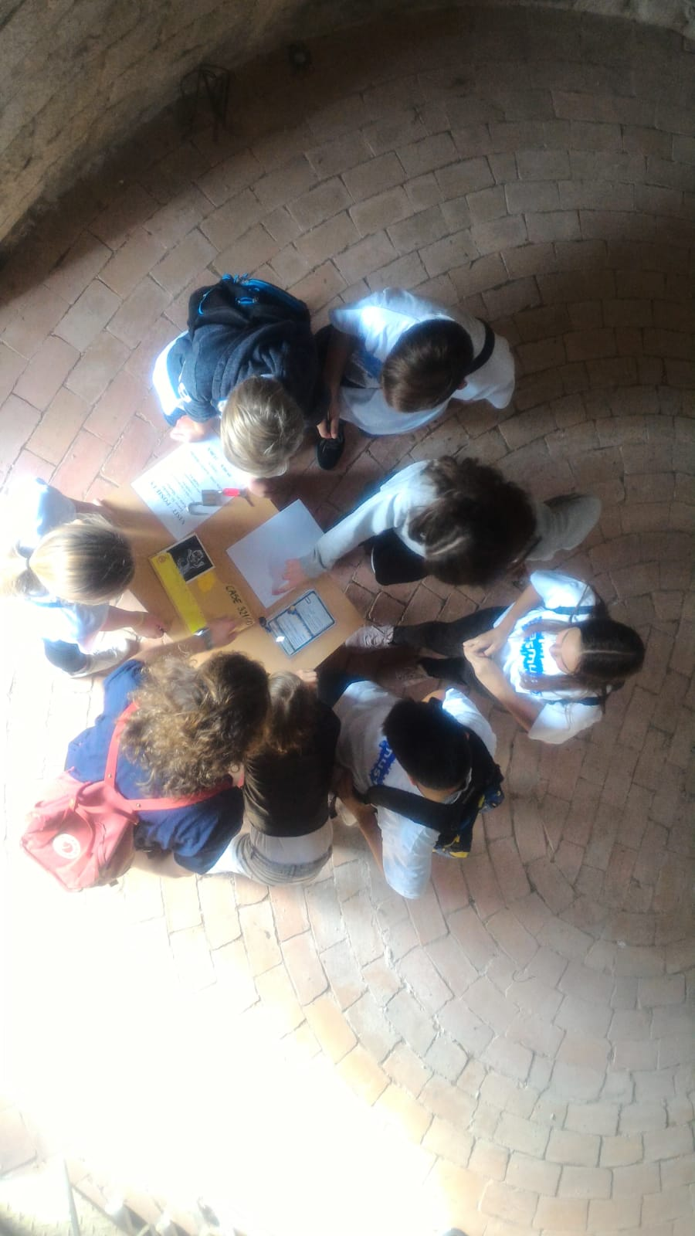
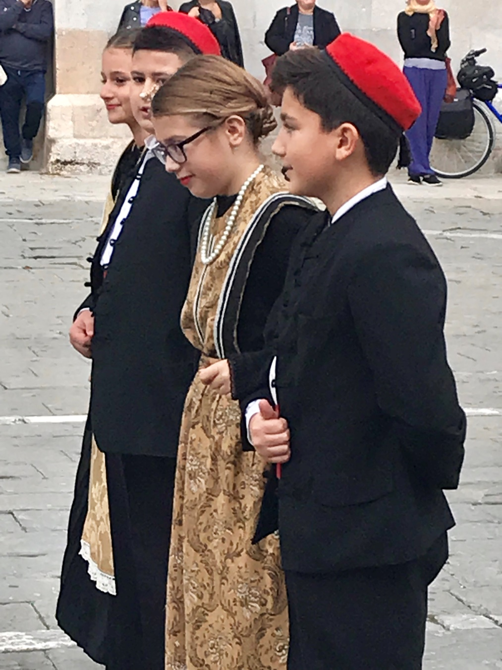
Tuesday 6th of November. The second day of the international meeting was full of amazing experiences, contacts with nature, history and loud conversations. We gathered outside the school at 8:30 and set off on a trip to the Krka National Park. It’s a large beautiful place with numerous walking paths,waterfalls, bridges and breathtaking views. The weather was perfect – warm and sunny so we walked around and admired wonderful waterfalls, plants and landscapes. We even visited the Ethno Village and got information about first hydro power plants, famous inventors and agricultural devices. In the meantime the groups of students had to face some mathematical problems. Luckily, despite initial language difficulties they did really well and quickly. Very smart teenagers! Later we had some time to laze a little in the sun and then it was time to get ready for lunch. We ate it in a posh restaurant where we could taste delicious Croatian dishes. And those with a sweet tooth relished very good ice cream… . After lunch we head for Sibenik-a lovely seaside town with UNESCO treasures. We saw a real UNESCO architectural masterpiece – St. Jacob’s Cathedral and walked along narrow winding streets and the beautiful coastline. The Polish team even found time to dabble in the sea for a while. The whole day was perfect – it included nature, history, cultural heritage and friendship – it seems that everybody overcame their shyness and started to socialise and cooperate really well.
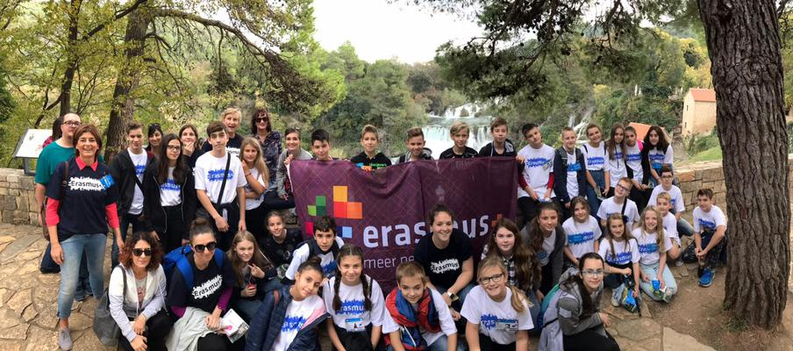
Monday 5th of November 2018. Last weekend all schools have arrived in Seget Donji! That means we are ready to start! In the morning we walk together to our first host, the Kralja Zvonimira school. At the enterency the flags of all our country’s and the big purple Erasmus flag are flauting in the wind and we directly feel very welcomed. Croatia, our host, has organised a beautiful welcome programme with a lot of kind words, the national anthem and some dance and live music presentations. Then all the country’s are called up to the stage to receive some very nice presents. Also we get a t-shirt to wear this week so everybody will recognise us. Each country brought some plant and flowers which we plant together in the school garden, as a symbol for our new friendship. Then it’s lunchtime! The students eat together, like the teachers do as well. We really enjoy all the delicious food, even Christian who didn’t even like seafood before (now he does!). We get really spoiled with all the pasterys the parents from the students made for us. After lunch there are some workshops, which the students follow. In each group there is one student of each country. We learn a lot from the Croatian history and heritage. We follow workshops as making bookmarks, dry wall building, crime scene math, building stone houses, Glagolitic workshop and Trogir pad workshop. Slowly we see our students to make there first connection with each other! After the workshops there’s some time for the teachers to come together and look back on a very special, perfect first day, while the student play outside. Tomorrow we will meet each other again and we are looking forward to it! ‘Men must think and speak only goodness’ (This secret message which comes to us throughout the centuries can be very well used for a modern man as well) Glagolitic workshop
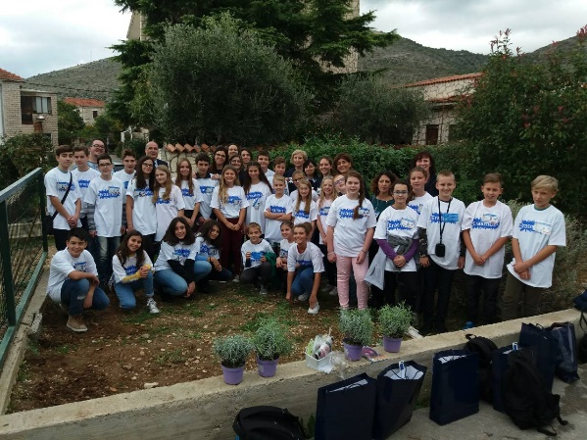
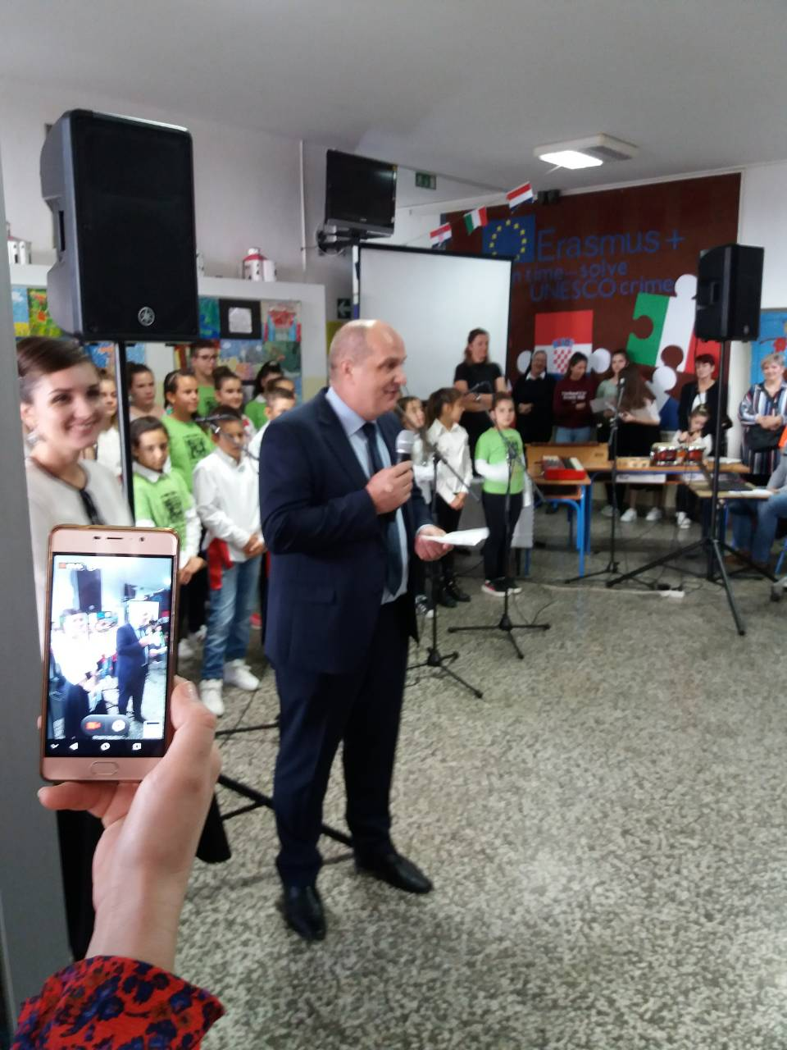
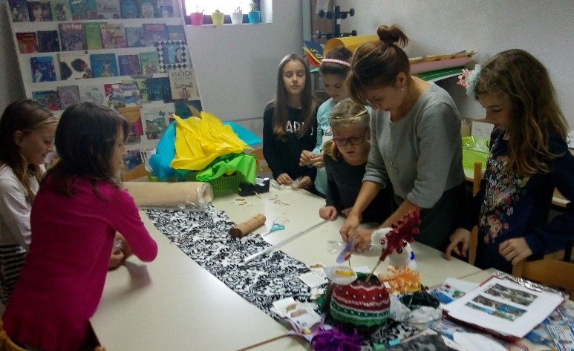
Making a huge 4meters* 1.8 meters advertisment for our central activity 7.11. 2018.
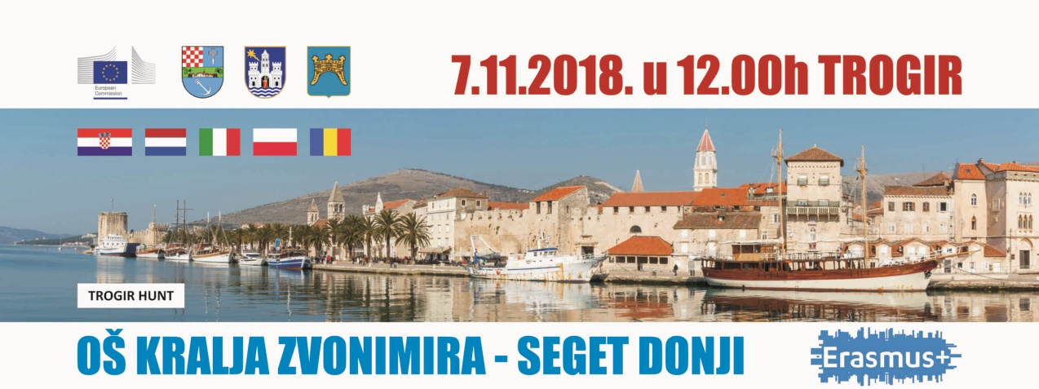
acreditation for kids and teachers
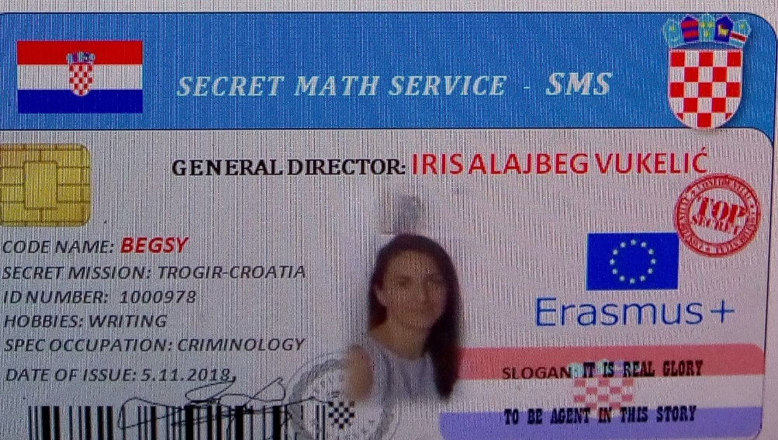
Our first visit on local radio Trogir to promote this Erasmus project
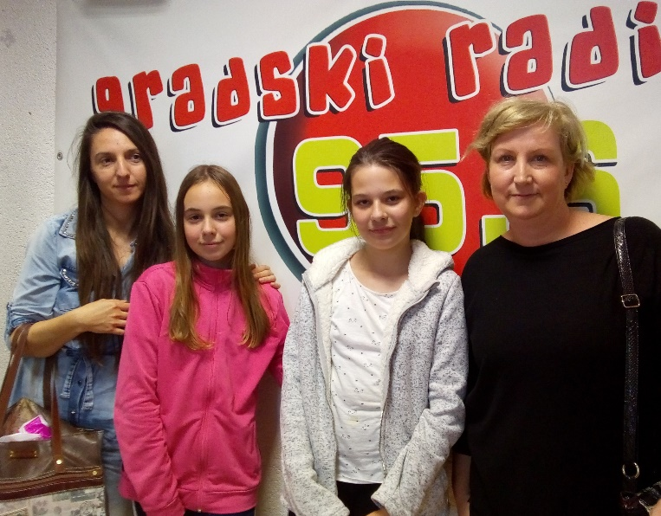

AKTIVNOSTI NIZOZEMSKA DIGITAL
Time flies, especially when you are having fun! And that's what we had together during this week.
Today we started with our STEAM time song and learned about The Woudagemaal and The Bilderdijk Mills, all UNESCO world heritage. Then we had a nice workshop Delfts Blue and a KAHOOT with a lot of questions about STEAM time and about Dutch UNESCOI heritage. The Certificates of Attendance were awarded and after that we said goodbey tot each other. At last, when all our pupils had gone home, all participating teachers toasted to the succes of our porject with Schrobbelèr, a tipical Tilburgs drink. We all felt proud and happy because we could have closed our project this way.
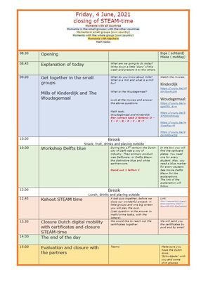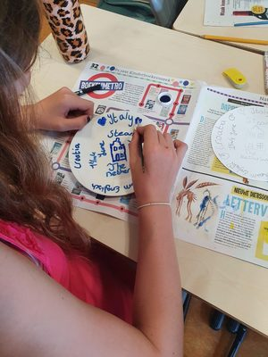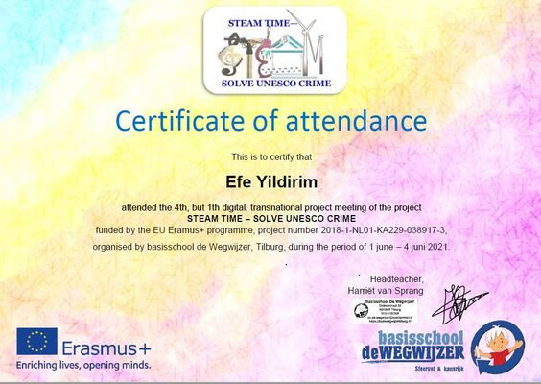​​​​​​
Today was the third day of our digital mobility organised by the Netherlands. It was a very busy day and full of very interesting activities! We started the day sining all together our song, the STEAM time - solve UNESCO crime song. Then we saw a video about the textile museum from the Textilemuseum in Tilburg and we tried to recreate a weaving pro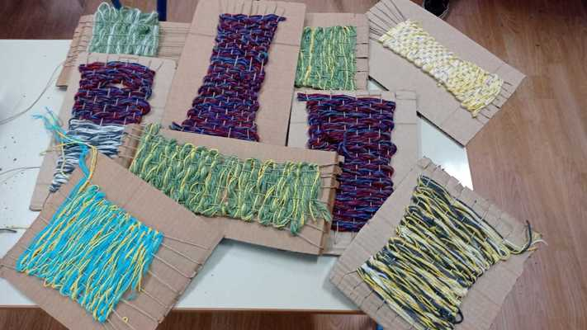duct with needle and thread ourselves.
Aftre this we learned and experimented to draw like Vincent van Gogh with the help of the art teachers from Vincents drawingroom in Tilburg. We solved math tasks about Vincent van Gogh and the Efteling, a big themepark by Tilburg. We solved problems in de digital escape room about Dutch and Tilburg heritage. In the end it was really nice to share our emotions and try to get to know our European friend by video call. We are looking foreward to tomorrow!
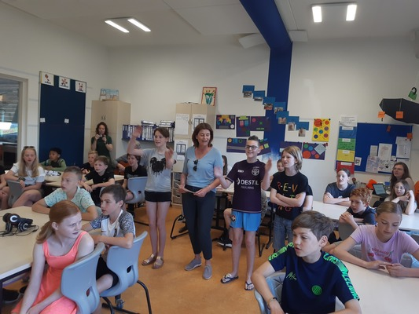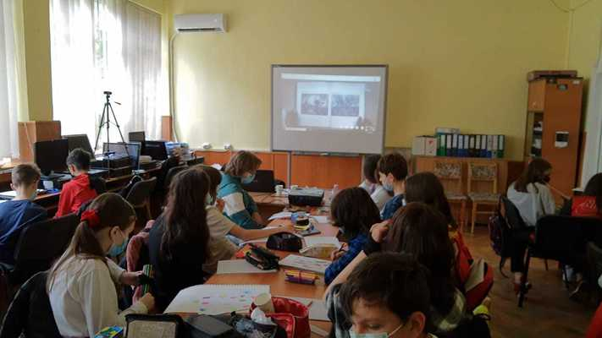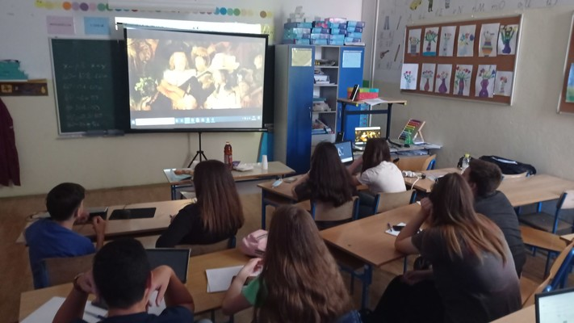
STEAM time goes digital
Day 2.06.2021.

Started with the online meeting with the partners explaining today plans of the program and singing the STEA song....lalala.....with our kids each country by herself disccussed about Dutch herritage and who is Anne Frank.
Together in our small groups we watched the digitaly guided tour of Amsterdam after which we were solving math tasks collecting the clue letters after solving the task.
Second part of the program today inclouded the Rijksmuseum digital tour and digital escape room Experiencing Night Museum which was very interesting. After we have solved the task and escaped the room succesfully we had guided tour through the Anne Frank Museum and about Annes life and death. In groups on Microsoft Teams app with pupils from partner countries we have solved more math tasks which were very interesting and in conection with Dutch Unesco Heritage.
We had great time together, we have learned a lot and we are excited to learn more.
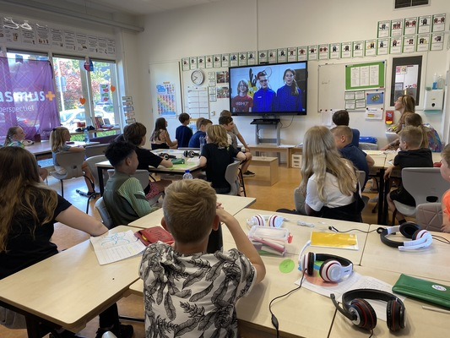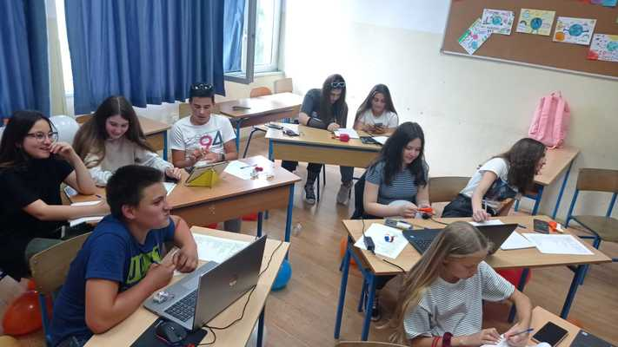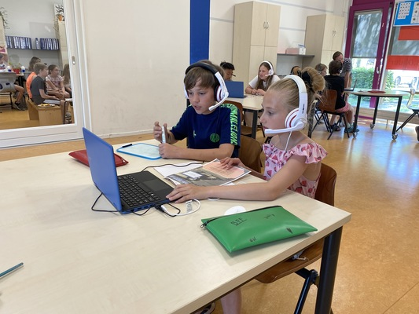

  - Like
  - Comments
  - Edit
  - Delete
  - Pin
Today we started the digital exchange of our project STEAM time - Solve UNESCO crime with wich we will close this beautiful ERASMUS + project. We prepared a nice digital programm for our partners from Romania, Italy and Croatia. It was the first time for all of us to use technology in this way. Exiting, sometimes difficult but also very energizing. We did it! We can be proud of our pupils showing us they can work, play, sing and dance together even if being in their own countries.
At this first day we started with a digital check and when everybody was online we watched each other's introduction videos, the opening dance https://youtu.be/h5l22Xw-Ksc and the STEAM time song https://youtu.be/DROVx9weCJ8
After that, our pupils met through teams. They learned to know each other by interviewing each other. After the break they made some math tasks about UNESCO World Heritage the Wadden Sea.
In the afternoon we played Song Bingo via Teams. We danced and played together and the great Bingo winner was Croatia. After the closure of the first day, the teachers had a meeting in wich they evaluated the day.
Tomorrow we start the day with music! Via Teams we will practice the STEAM time song all together:)
The Dutch National Agency has included an interview about the project STEAM time-Solve UNESCO crime in its annual magazine.
The title of the interview is: We plant a seed for the rest of their lives. It's written in Dutch.
Interview STEAM time
Best regards, Harriët
On Wednesday November 6 we had a digital meeting by Teams to renew our collaboration in this difficult Corona time. Some countries are in a lock down now so we decided to use e-Twinning as a way to allow our students to interact with each other. The Croatian partner will take the initiative to share some tasks that all pupils involved, can work on.
Because of the Corona pandemic and the lockdowns we have had to do with, our project has been halted for a while. Unfortunately the exchanges to Poland and The Netherlands could not coninue. The local authorities and the school directors from Poland decided for good reasons to cancel all meetings connected to European projects. Therefore the Polish part of the project STEAM time- Solve UNESCO crime ended on August 1, 2020.
The other partners will continue the project until August 2021. The final meeting will take place in The Netherlands in the week of April 19, 2021. In the meantime several digital meetings and activities for our pupils will be planned. We will keep you informed!

