STREAMing through Europe

The first day where the story of this fairytale begins.

Today all the students and teachers met each other at the school: De Wegwijzer. First the headmaster Harriët spoke some nice words of welcome. This week’s theme is about fairy tales. A fairy tale is originally a folk tale with a lot of fantasy as the main ingredient. It usually starts with the familiar words 'Once upon a time...' Despite the fact that there is a lot of fantasy and magic in it, there is often a deeper wisdom, or life lesson behind it. So we can learn a lot from fantasy stories.
Harriët red the fairy tale of the Indian Waterlilies.
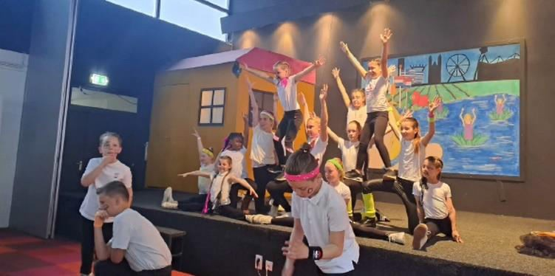

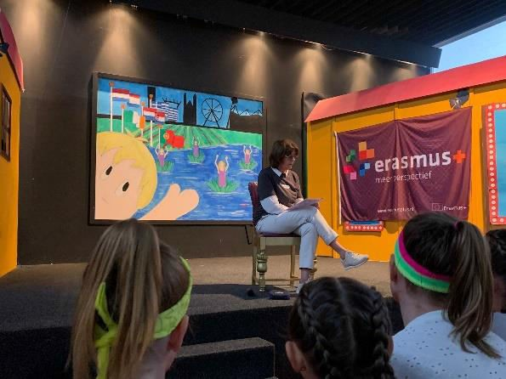

Afterwards all the countries made or prepared something to show to each other. The Dutch students showed a beautiful dance performance, Greece showed the most beautiful parts and taught us a dance, Ireland told and showed us about the music and sports and Portugal prepared a presentation.

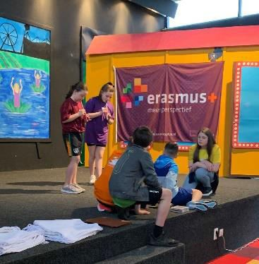
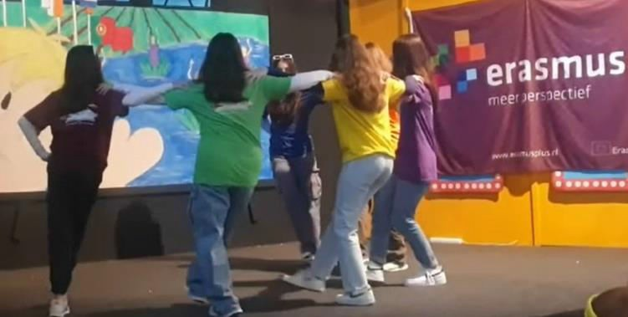

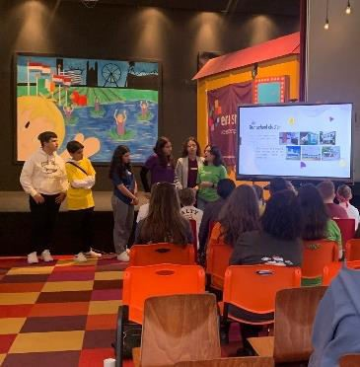

The workshops started at 10.15 am. Here the children were introduced to Dutch arts, dance, music and book art. After the workshops we had a typical Dutch lunch. We ate: worstenbroodjes(sausage in bread), hagelslag (sweet sprinkels), schuddenbuikjes and more delicious food.

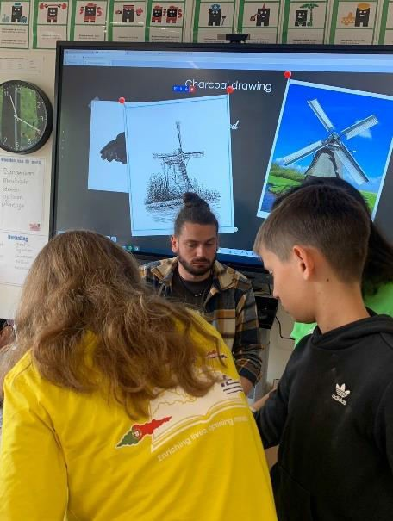

When the lunch was finished we took the bus to the dunes. Here we had different activities in which we learned a bit about Vincent van Gogh an nature arts. During the activities the students the students talked to each other about the difference between there counties and enjoyed the nature arts they made together.
It was a nice beginning for Erasmus STREAMing through Europe fairytale. This week we will live full of joy, new friendships and experiences. Like a fairytale with deeper wisdom and life lessons.

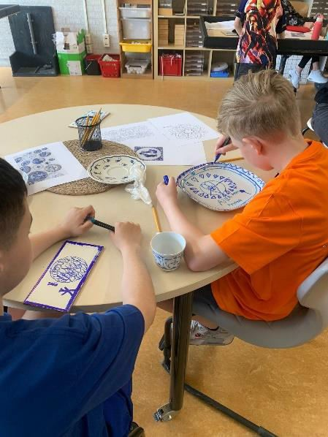
On May 11th, everyone headed to the Basisschool de WEGWIJZER.

There the touring car took us to the amazing fantasy-themed amusement park. We were feeling sleepy on the bus and then suddenly woke up in Efteling.

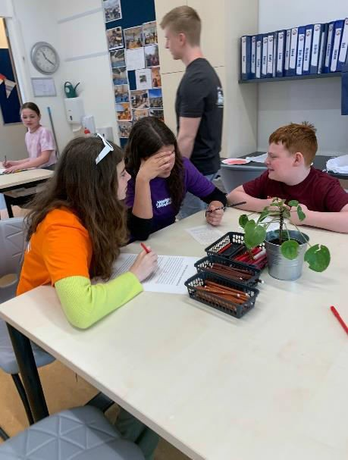
There we could meet the Indian waterlilies dancing gracefully with their glittering dazzlingly dresses, the star children, the moon goddess and even the ugly witch.
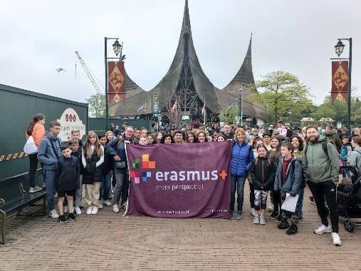
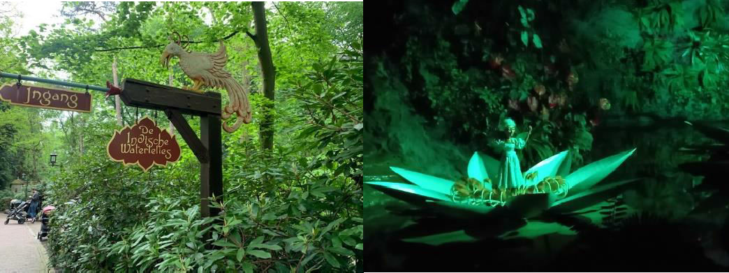

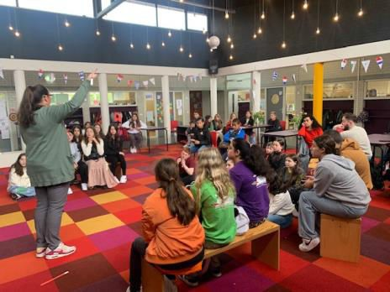
Efteling is such a unique park in the middle of nature with exciting roller skaters, enchanting attractions and spectacular park shows

which caters to both children and adults with its cultural, romantic, and nostalgic themes.
The barbecue at school with the host families, teachers and all the Erasmus + partners was such a pleasant, heartwarming, and inspiring closing of the day.

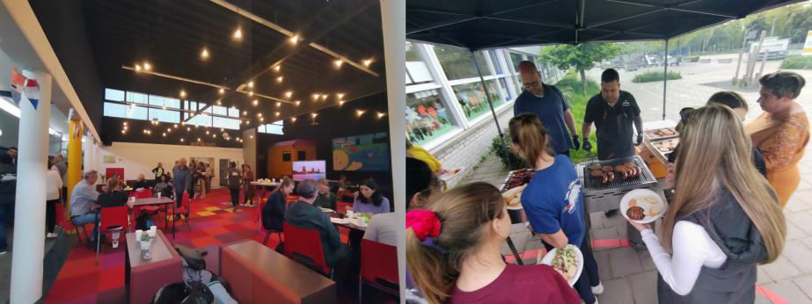

Day 2: Amsterdam and Muiderslot
On Tuesday morning, it was time to visit the capital, so we all took the bus to Amsterdam. The weather was rainy and dark but the spirits were bright. After spending what seemed like an eternity on the bus, we finally arrived in the city with the beautiful buildings and the wonderful water ways. Under pouring rain, we reached the boat that would take us on a tour around the canals. We went under beautiful bridges, saw wonderful houses and, of course, hundreds of bicycles!

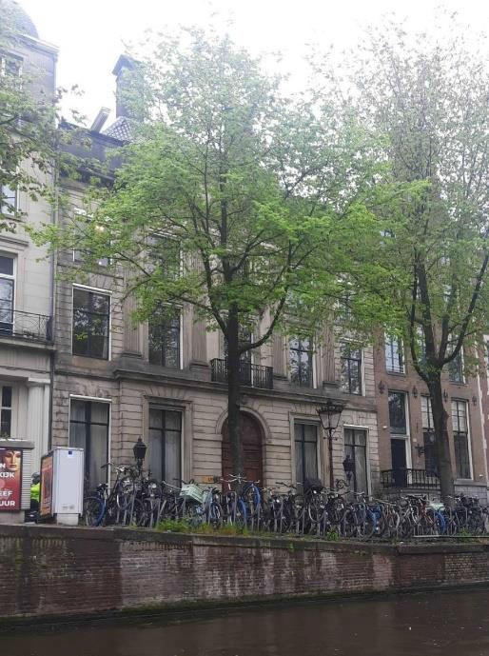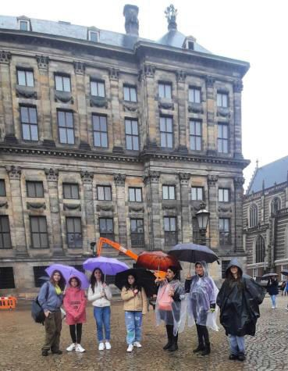

After the boat trip, we spent some time in the city, walking around, taking pictures. We had a quick lunch and set off for the castle of Muiderslot. We went in the castle, starting our guided tour from the medieval dungeons. We also visited the kitchens, we saw the heavy suits of armour that knights used to wear and learnt about the history and traditions of the castle. We heard that the gardens were great, but unfortunately, we couldn’t visit them as the weather wouldn’t let up.

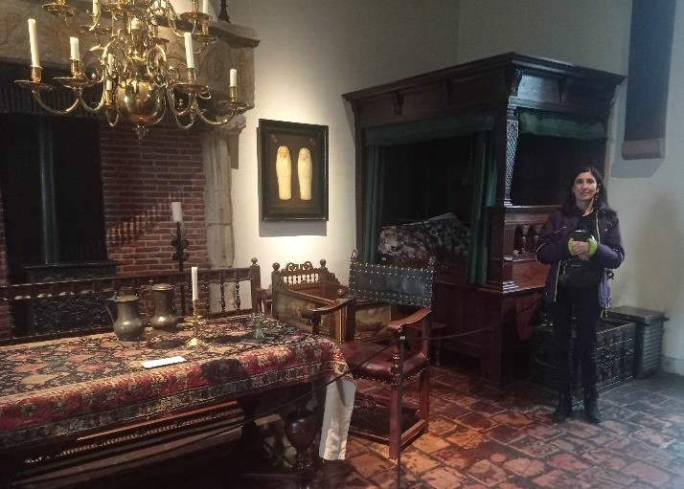

In the afternoon, we returned to Tilburg filled with beautiful images and memories of the day…

Friday 12th May 2023

Today we visited Tilburg’s biggest library where we talked about fairy tale’s and what
components make up a fairy tale e.g. character, location etc.
The children all went to their respective colour groups and began working together to create new fairy tales, using very helpful word cards to help them on their way.
As I looked on, I could see that all the children mingled, talked and joked with each other in a way that only friends do.
Over the past week the awkwardness and shyness with which they arrived with to The Netherlands had all but vanished.
All groups read their stories aloud and laughed and giggled at the finished tale.

Before we left the Library, I had a walk around so I could have a proper look at the different spaces within the library and bizarrely enough the fist shelf I glanced at had a book facing me - Desiderius Erasmus whom our project is funded by.
We were all presented with our certificate of attendance and a beautiful recipe for the lovely Tomato soup we all had taste during the week.

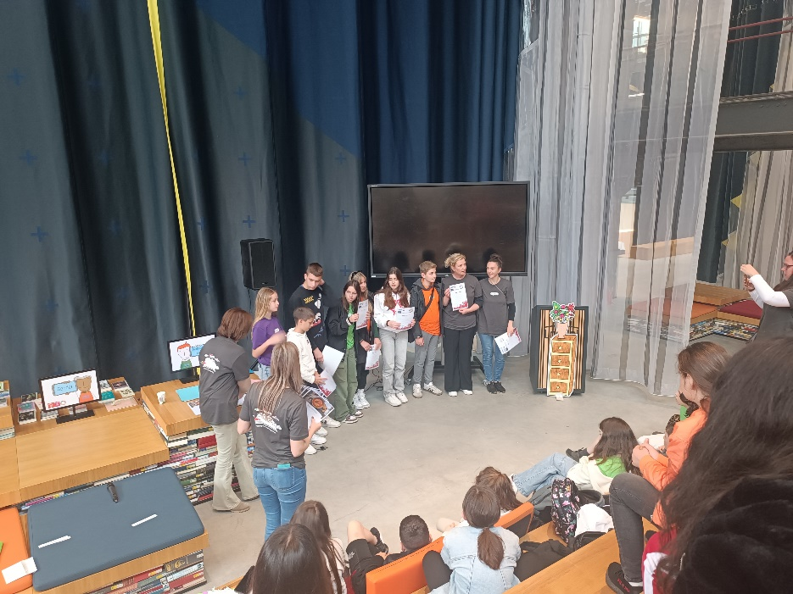
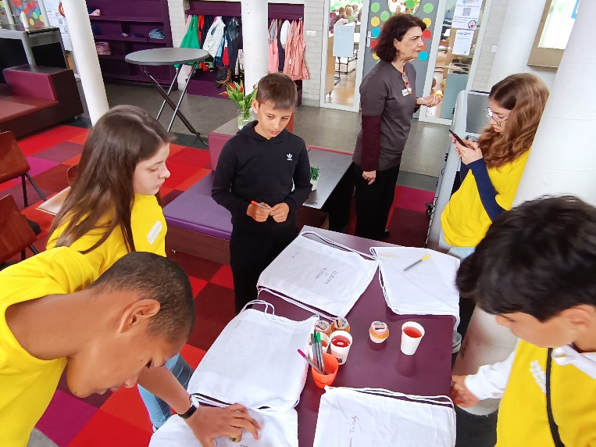
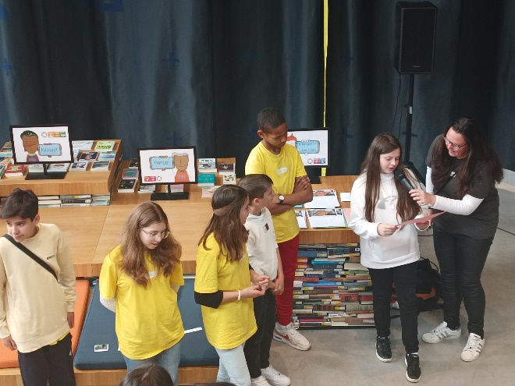

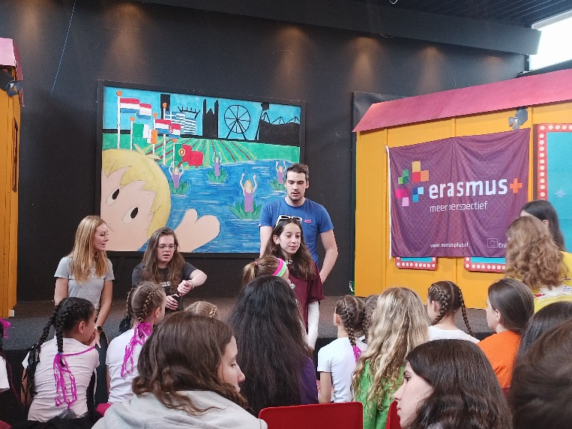
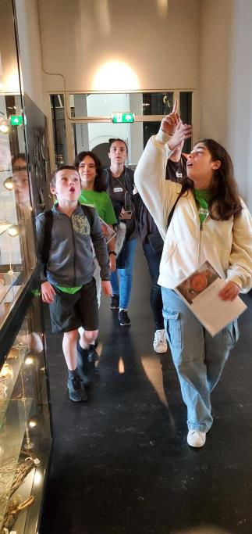
After the beautiful visit to this massive library which was really a beautiful community space, we walked the short distance to the Natural History Museum and once again the children were all mixed up and taken around to the different spaces within the museum. We the teachers also accompanied the children through the museum and helped with any questions that needed answering.

As we gathered up the children so as we could go to get lunch I couldn’t but feel sad at the thought that they, the children, didn’t realise that their time together with their newly made friends would soon come to an end. For a while their communications with each other would be via phone or computer until they would meet again. For all of us involved in this project Europe has become a smaller place.

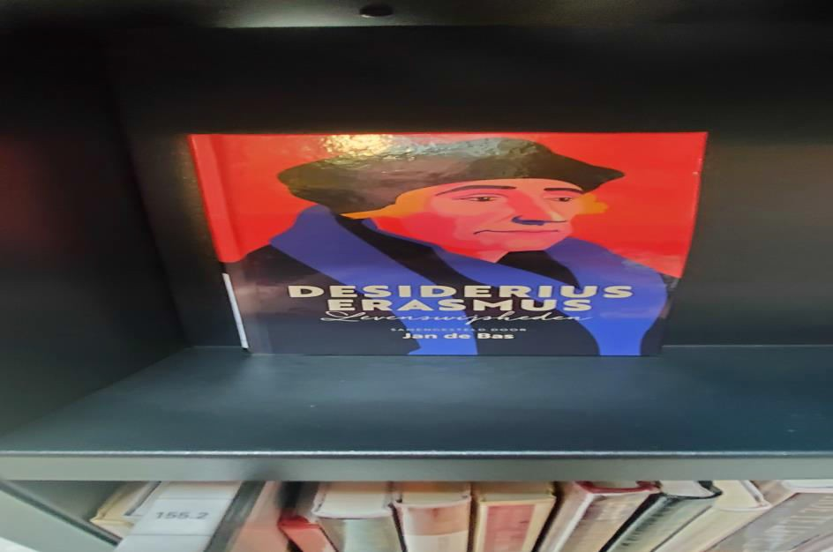

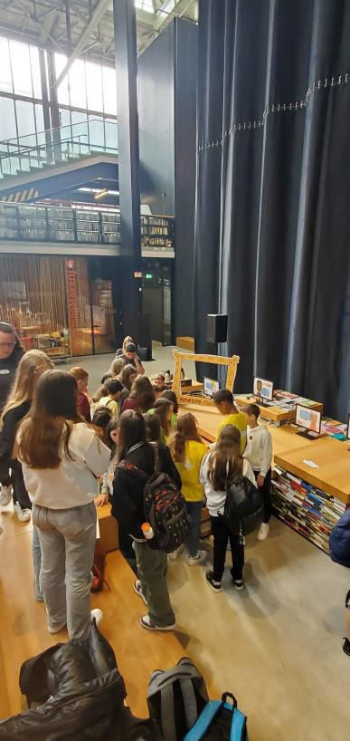
As we sat eating and talking during our meal all involved realised that our project has come to an end on paper only but in reality, it is the beginning of a natural want to stay in contact and hopefully arrange many more face-to-face meeting – bringing people and places together.

Inevitability we all had to say goodbye, the penny had finally dropped as they say – it was suddenly realized we all must part company for a time. Teardrops fell and hugs were given and friend parted who would not have meet if it hadn’t been for this Erasmus + project.
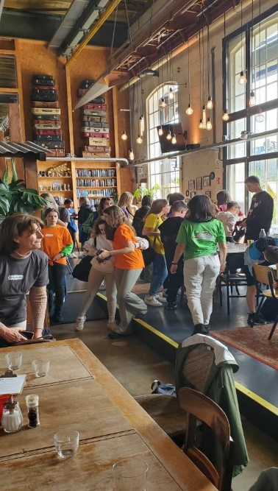
All the different groups gathered and went their separate ways waving as the departed. We the Irish sat in the sun as we awaited our taxi. I listened to the children tell tales of their week and the friends they meet and the cultural difference they noticed and the new word they learnt it was a delight to listen to their stories and look at the photographs they took.

This Erasmus + project gave them something they could never learn in a classroom setting.This unique experience which we all experienced will only help our respective communities as the travellers return home and tell their tale. As Erasmus himself said – “ Give light and the darkness will disappear of itself”

